Anatomy Quest: A 2D Interactive Learning Game

A Capstone Project

Presented to the Faculty of the

College of Computer Studies

Carlos Hilado Memorial State University

In Partial Fulfilment

of the Requirements for the degree

BACHELOR OF SCIENCE IN INFORMATION TECHNOLOGY

by

Alex S. Amar Jr.

Rexel Babe N. Borres

Justine E. Miladona

May 2025

**TABLE OF CONTENTS**

**PAGE**

TITLE PAGE 1

TABLE OF CONTENTS 2

LIST OF FIGURES 4

LIST OF TABLES 5

CHAPTER

1. INTRODUCTION

Background of the Study 6

Objectives of the Study 7

Significance of the Study 9

Scope and Limitation 10

Definition of Terms 11

1. REVIEW OF RELATED LITERATURE

Title of your literature 15

Synthesis 19

1. METHODOLOGY

Research Design 20

Research Respondents 21

Sampling Techniques 22

Data Gathering Instrument 23

Data Gathering Procedure 22

Validity of the Research Instrument 24

Reliability of the Questionnaire 25

Analysis / Statistical Treatment of Data 25

Ethical Consideration 26

System Development Life Cycle 26

Operational Framework 30

Context Diagram (Level 0) 31

Data Flow Diagram (Level 1) 32

Entity Relationship Diagram 33

Use Case Diagram 34

Data Dictionary 36

Hardware Requirements 40

Software Requirements 41

Timetable (Gantt Chart) 42

REFERENCES 44

**LIST OF FIGURES**

Figure No. Figure Title **PAGE**

1 Prototype Model 27

2 Operational Framework 31

3 Context Diagram(Level 0) 32

4 Data Flow Diagram (Level 1) 32

5 Entity Relationship Diagram 32

6 Use Case Diagram(level 1) 32

7 Gantt Chart 32

**LIST OF TABLES**

Table No. Table Title **PAGE**

1 Matrix of Related Literatures and Studies 17

2 Respondents’ Profile 20

3 5-Point Likert Scale and Verbal Interpretation 22

4 Actual students Table 35

5 Actual Teachers table 35

6 Actual modules table 36

7 Actual stories table 36

8 Actual quizzes table 37

9 Actual scores table 38

10 Server and Client (Desktop Computer) 39

11 Hardware Requirements 40

Chapter 1

**INTRODUCTION**

**Background of the Study**

Today, education has improved a lot with the use of technology, making learning fun and easy for kids. Digital tools like educational games, videos, and apps help students understand lessons better and remember information more easily. Online learning also allows children to study anytime and anywhere, giving them more chances to learn at their own pace. The changes in digital learning are very helpful for young learners, making education more interactive, interesting, and effective.

Education has greatly evolved with the integration of technology, providing interactive and engaging ways for children to learn. Traditional learning methods, such as textbooks and flashcards, often fail to capture the attention and interest of young learners. According to Gee (2003), digital games can enhance learning by providing problem-solving experiences that engage students in meaningful ways. To address this challenge, educational games have become an effective tool for enhancing knowledge retention, improving engagement, and making learning fun and interactive.

Anatomy Quest: A 2D Interactive Learning Game is designed to help young learners understand and familiarize themselves with human body parts in an engaging and immersive way. By utilizing a 2D graphical user interface (GUI), this game provides an interactive platform where children can explore different body parts, learn their names and functions, and reinforce their knowledge through fun activities and quizzes. Research by Plass, Homer, and Kinzer (2015) suggests that interactive digital learning experiences can improve cognitive development and motivation in young learners. The game incorporates visually appealing graphics, sound effects, and interactive elements that cater to the cognitive learning needs of children.

The need for such educational tools arises from the growing reliance on digital learning materials in schools and at home. Many children find traditional learning methods boring, leading to a lack of interest and motivation. With the increasing accessibility of smartphones, tablets, and computers, using digital games for education can make learning more accessible and enjoyable for young learners.Studies by Wang et al. (2014) highlight that game-based learning can significantly improve engagement and learning outcomes in children.

This project aims to bridge the gap between learning and entertainment by providing a creative educational game that enhances children's knowledge of body parts while keeping them engaged. By integrating interactive learning techniques, Body Explorer can serve as a supplementary learning tool for teachers, parents, and students, supporting early childhood education in an enjoyable and effective manner.

**Objectives of the Study**

The main purpose of the study is to develop “Anatomy Quest: A 2D Interactive Learning Game" for the primary school's science class. Specifically, this aims to achieve the following:

1. Design and develop an interactive web-based learning platform with the following technical features:

1.1. Manage class and lessons plans, monitoring of learners specifically achievements.

1.2. Uploading of questions/contents.

2. Develop a mobile version of the platform with the following features:

2.1. Provide lessons and interactive activities for body parts

2.2. Develop a step-by-step guide for the learners with challenges in each level.

2.3. Provide a user-friendly interface with easy access to lessons, quizzes, and mini-games.

2.4. Provide engagement through rewards, rankings and feedback to keep learners motivated.

3. Test the functionality of the aforementioned above:

4. Evaluate the System Using Standardized Evaluation Tool in Terms of:

4.1. Functional Suitability

4.2. Performance Efficiency

4.3. Usability

4.4. Compatibility

4.5. Reliability

4.6. Security

4.7. Maintainability

4.8. Portability

**Significance of the Study**

The Anatomy Quest: A 2D Interactive Learning Game is designed to be significant and beneficial to the following groups:

**Primary Students.** .are typically in early education, ranging from **kindergarten to grade 6. They are in the process of developing foundational knowledge and skills. These students benefit from interactive and engaging learning methods which help them understand complex concepts in a fun and effective way.

**Teachers.** are educators who guide students in learning and development. This study benefits them by providing an interactive teaching tool that makes anatomy lessons more engaging, helping students better understand and retain information.

**Parents.** are guardians responsible for their children's growth and education. This study benefits them by providing a home-based learning tool that supports their child's education, making learning more accessible, interactive, and enjoyable.

**Researchers.** are individuals conducting studies to explore and improve educational tools. This study benefits us by providing valuable insights into how interactive learning enhances student engagement and comprehension, contributing to the advancement of educational technology**.**

**Future Researchers.** are individuals who will conduct studies to improve educational tools and learning methods. This study benefits them by providing useful data and insights on the impact of interactive learning games, serving as a foundation for further research and innovation in educational technology.

**Scope and Limitation**

The study focuses on creating a learning game called "Anatomy Quest: A 2D Interactive Learning Game." The game is made to help young kids learn the names of basic body parts. Making a 2D game that users can click and interact with. Putting fun things in the game like quizzes, stories, animations, and sounds to make it more interesting and help kids learn. Aiming the game at kids in the elementary school. Checking if the game helps kids remember the names of body parts. Looking at how well things in the game work to help kids learn. Making sure the game can be used on different devices like computers, tablets, and phones. Testing the game with a small group of students, teachers, and parents from some schools.

Despite its potential benefits, the study has certain limitations. The study has some things it does not include: While the game is designed for elementary students (Grades 1-6), it may be more effective for introducing basic anatomy concepts to students in the lower elementary grades (Grades 1-3). The content may not provide sufficient depth or complexity to fully address the anatomy learning objectives of students in the upper elementary grades (Grades 4-6), whose curriculum typically includes more detailed studies of organ systems and physiological processes. The game's level of engagement and challenge may vary across the developmental range of elementary students (Grades 1-6). Certain game mechanics or content elements might be better suited for younger learners, while older students may require more advanced or complex interactions to maintain interest and maximize learning. The study gathers feedback on the game from a limited number of participants. This sample may not fully represent the diverse learning needs, preferences, and technological proficiencies of all students within the elementary grade range (Grades 1-6). The study does not compare the game's effectiveness to other instructional methods or existing anatomy curricula used in elementary schools through a rigorous, controlled experimental design. This limits the ability to make definitive claims about its comparative benefits or overall impact on anatomy education within elementary schools. The use of the game requires access to digital devices (exp. smartphones, tablets, computers) and internet connectivity. This reliance on technology access may present a barrier for some students across the elementary school population, potentially limiting the game's equitable implementation and use

**Definition of Terms**

This section defines the essential ideas mentioned in the study. As a result, each topic is described in contextual and operational terms to help readers comprehend the study

better. The contextual name for the terms refers to their general definition, while the operational term refers to how or where they are employed, depending on the study.

**Anatomy.** Conceptually, the scientific study of the body and how its parts are arranged (CambridgeDictionary, 2025).

As used in this study, anatomy serves as the foundation for the system, providing interactive visuals and activities to help learners understand body structures and functions in an engaging way.

**Human Body.** Conceptually, the physical structure and material substance of a human being, consisting of many billions of cells as well as components outside of the cells. The average adult human body is 50–65% water. (Dictionary.com, 2025).

Based on this study, the human body serves as the main subject of Anatomy Quest: A 2D Interactive Learning Game, where students can explore its structures and functions in an interactive way. The game uses visuals, quizzes, and activities to help learners better understand and retain information about the different body systems.

**Lessons.** Conceptually, a period of time in which a person is taught about a subject or how to do something. (CambridgeDictionary, 2025).

Operationally, lessons in the system are designed as interactive modules that teach students about body structures and functions. These lessons incorporate visuals, quizzes, and activities to enhance engagement, making learning more effective and enjoyable.

**Mini Games.** Conceptually, A minor or incidental game within a larger video game.(YourDictionary, 2025).

As used in this study, mini-games enhance Anatomy Quest by making learning more engaging and interactive. These games reinforce anatomy concepts through challenges, quizzes, and activities that encourage active participation and improve knowledge retention.

**Science.** Conceptually, knowledge or a system of knowledge covering general truths or the operation of general laws especially as obtained and tested through scientific method (MerriamWebsterDictionary, 2025).

In this study, science is applied in the system by presenting accurate and detailed information about the human body. The game integrates scientific concepts with interactive features to help learners explore anatomy in a fun and engaging way, improving their understanding of biological structures and functions.

**Quest.** Conceptually, refers to a long search for something that is difficult to find, or an attempt to achieve something difficult (cambridgedictionary,2025).

Operationally, quest represents the interactive and exploratory nature of Anatomy Quest: A 2D Interactive Learning Game. It engages learners in a journey of discovery, where they complete challenges, solve quizzes, and explore the human body in a fun and educational way, enhancing their understanding and retention of anatomical concepts.

**Quizzes**. Conceptually, a quiz is a game or competition in which someone tests your knowledge by asking you questions. (Raikar & Pai, 2021).

As used on this study, quizzes in Anatomy Quest: A 2D Interactive Learning Game serve as an interactive assessment tool to reinforce learning. They help students recall information, test their understanding of anatomy concepts, and track their progress in a fun and engaging way.

**Young Learners.** Conceptually, having lived or existed for only a short time and a person who is still learning.(Cambridgedictionary, 2025).

Operationally, young learners are children who are just starting to learn, usually in school or at home. The system is designed to cater to their learning needs by providing engaging visuals, interactive activities, and simplified explanations of anatomy concepts, making learning more fun and effective

Chapter 2

**REVIEW OF RELATED LITERATURE**

This chapter presents the related literature and studies from both local and foreign sources. Those were included in this chapter helps in familiarizing information that are relevant and similar to the present study.

**Class Management System**

Al-Kindi and Al-Khanjari (2021) developed the Tracking Student Performance Tool (TSPT), which analyzes Moodle logs to predict and monitor student engagement, behavior, personality, and performance. Similarly, Feoktistov et al. (2020) developed a digital platform for managing secondary vocational education, featuring subsystems for performance monitoring, personalized learning management, academic records, employment support, and virtual lab environments. Furthermore, Sergeev et al. (2021) developed an online educational platform that allows institutions to create customizable online courses, manage administrative tasks, and support interactive collaboration between teachers and students.

**Educational Content Management System**

Educational institutions have been using educational content management systems to organize, personalize, and deliver diverse learning materials more effectively in recent years. For example, Sherayzina et al. (2021) developed a framework for managing diverse educational content using information and educational environments. Similarly, Ouadoud et al. (2021) created an overview of free and proprietary e-learning platforms, detailing their functional architectures and the types of e-learning systems that can be developed from them. Moreover, Kubrak et al. (2023) developed a remote digital examination system for Munich University of Applied Sciences, enabling secure and competence-oriented online exams during the COVID-19 pandemic and beyond.

**Interactive Body Learning System (IBLS)**

Lamrani and El Hassan (2020), for instance, developed a digital play-based learning system that integrates serious games based on Montessori principles and the four pillars of learning, aiming to enhance children's skills and engagement in early childhood education. Similarly, Bains, Kaliski, and Goei (2022) introduced supplemental learning tools, combining nondigital materials and technology-enhanced resources to support self-regulated anatomy learning for physical therapy students, showing that nondigital tools significantly boosted engagement and practical exam performance. In addition, Astuti, Wihardi, and Rochintaniawati (2020) designed and evaluated an interactive educational website to support integrated science learning on human body levers, demonstrating positive acceptance and usability among junior high school students and teachers.

**Progressive learning system with challenges.**

Wang, Rao, Zhi, Marwan, Gao, and Price (2020) designed Step Tutor, an adaptive programming support system that provides struggling students with step-by-step example solutions, encouraging reflection and comparison to enhance both their progress and learning during independent coding tasks. In a related study, Doulougeri et al. (2022) examined the dynamic interplay and friction between student self-regulation and teacher scaffolding during a 9-week challenge-based learning course, highlighting how this interaction influences students’ transition to independent learning and suggesting strategies to enhance autonomy and collaboration. Furthermore, Bayounes, Bayoudh Saâdi, and Kinshuk (2022) proposed an intentional model within an Intelligent Tutoring System (ITS) that uses Map formalism and the ARCS motivation model to guide personalized learning by adapting strategies to individual learner intentions and motivations, aiming to streamline the learning process and provide multiple learning paths.

**Gamified Learning System**

Chang, Yang, and Yu (2020) developed Joyce, an online competitive learning system featuring multiple forms of competition and 16 activities, designed to motivate learners through gaming elements while promoting engagement and material review in a flexible, age-independent environment. In a similar vein, Borrelli and Perrella (2021) highlighted the critical role of user-friendly graphical interfaces (GUIs) in e-learning platforms, showcasing innovations implemented at their university to enhance student interaction, accessibility, and the continuity of education during the rapid shift to online learning. Moreover, Zainuddin, Shujahat, Haruna, and Chu (2020) examined the impact of using gamified e-quiz applications like Socrative, Quizizz, and iSpring Learn LMS as formative assessments in science classes, finding that gamified instruction enhanced student engagement and effectively supported learning performance compared to traditional paper-based quizzes.

**Motivational Learning System**

Hellín et al. (2023) introduced a web-based application that combines automated programming assessment with gamification elements to enhance motivation and engagement among programming students, finding that the tool increased students’ participation, self-confidence, healthy competition, and learning from mistakes. Similarly, Xiao and Hew (2023) investigated the impact of tangible rewards redeemed through intangible gamification elements on student motivation and engagement in a fully online gamified flipped classroom, finding that tangible rewards significantly enhanced intrinsic motivation, behavioral and cognitive engagement, and learning performance compared to intangible rewards alone. In addition, Miri et al. (2022) conducted a multiple case study analyzing how gamification promotes employee motivation and engagement in the workplace, finding that careful planning of game design elements like scoring, feedback, and rewards is essential for successfully enhancing engagement and motivation.

**Table 1**

*Matrix of Related Literatures and Studies*

|  |  |  |  |  |  |  |
| --- | --- | --- | --- | --- | --- | --- |
| **RRL** | **Features** | | | |  |  |
| Studies/System | Feature 1 | Feature 2 | Feature 3 | Feature 4 | Feature 5 | Feature 6 |
| **Class Management System** | ✓ | ✓ | ✓ | ✕ | ✓ | ✕ |
| **Educational Content Management** | ✕ | ✓ | ✓ | ✕ | ✓ | ✕ |
| **Interactive Body Learning System (IBLS)** | ✕ | ✕ | ✓ | ✓ | ✕ | ✕ |
| **Progressive learning system with challenges** | ✕ | ✓ | ✓ | ✓ | ✕ | ✕ |
| **Gamified Learning System** | ✕ | ✓ | ✕ | ✕ | ✓ | ✓ |
| **Motivational Learning System** | ✕ | ✓ | ✕ | ✓ | ✓ | ✓ |

Synthesis

Today’s education relies on different systems working together to make learning easier, more engaging, and well-organized. A Class Management System helps teachers plan lessons, organize classes, and keep track of how students are doing. At the same time, an Educational Content Management System lets educators organize and deliver all kinds of learning materials, making it easier to personalize lessons for different students.

For subjects like anatomy, an Interactive Body Learning System (IBLS) provides hands-on, visual lessons that help students understand complex ideas through interactive tools. Then, a Progressive Learning System with Challenges breaks learning into smaller steps, with each level presenting new challenges that help students build skills gradually.

To keep students motivated, a Gamified Learning System adds game-like features such as points, badges, and competitions, making learning more fun and encouraging students to participate. Alongside this, a Motivational Learning System uses feedback and rewards tailored to each learner to keep them engaged and motivated throughout their learning journey.

All these systems together create a balanced approach to education — making sure learning is organized, personalized, interactive, and motivating for students.

Chapter 3

**METHODOLOGY**

This chapter overviews the methods used to attain solutions to the current situation. It includes the research design, data gathering procedure, data instrumentation, study population and sample, data treatment, and mobile app development process methodology.

**Research Design**

This study employed both Descriptive and Developmental research Design. Descriptive research aims to accurately and systematically describe a population, situation or phenomenon. It can answer what, where, when and how questions, but not why questions. A descriptive research design can use a wide variety of research methods to investigate one or more variables. Unlike in experimental research, the researcher does not control or manipulate any of the variables, but only observes and measures them (McCombes, 2023).

Meanwhile, in conjunction with this, Developmental research designs are techniques used particularly in lifespan development research(iastate.pressbooks.pub, 2022). According to(Seels & Richey, 1994, p. 127), Developmental research, as opposed to simple instructional development, has been defined as "the systematic study of designing, developing and evaluating instructional programs, processes and products that must meet the criteria of internal consistency and effectiveness”

**Research Respondents**

The study involved a carefully selected group of 15 participants who were directly engaged with the Anatomy Quest system. This group included both students and teachers who had relevant experience in using educational tools for anatomy learning. The student respondents actively participated in the system's gamified learning activities, while the teachers contributed by managing lessons and tracking student progress. Their involvement ensured that the study captured perspectives from both end-users and facilitators. This purposive selection was crucial for gathering meaningful insights into the system’s usability, effectiveness, and overall learning impact. The table below presents the profiles of these respondents.

**Table 2**

*Respondents’ Profile*

|  |  |  |
| --- | --- | --- |
| **Category** | **No. of Respondents** | **Percentage (%)** |
| Students | 10 | 66.67% |
| Teachers | 5 | 33.33% |
| **Total** | **15** | **100%** |

***Note. This table presents the distribution of respondents based on category.***

**Sampling Techniques**

The purposive sampling technique was utilized in this study since Anatomy Quest employed descriptive and developmental research. Purposive sampling is a non-randomized sampling technique that selects sampling units based on certain criteria. Purposive research sampling is a non-probability method whereby the researcher selects a sample (individuals, cases, or events) based on their judgment that it would be appropriate for achieving the goals of the study (Bisht, 2024).

**Data Gathering Instrument**

Researchers employed a standardized evaluation tool based on the ISO/IEC 25010:2011 Software Quality Model to assess the quality attributes of *Anatomy Quest: A 2D Interactive Learning Game*. This international standard evaluates software quality through eight key attributes: functional suitability, performance efficiency, compatibility, usability, reliability, security, maintainability, and portability. It also considers five quality-in-use aspects: effectiveness, efficiency, user satisfaction, risk mitigation, and contextual adaptability (Assifa et al., 2023). The assessment utilizes a structured questionnaire aligned with ISO standards, using a 5-point Likert scale (1 = Strongly Disagree to 5 = Strongly Agree) to ensure consistent and objective quality measurement. The tool’s format and content have been reviewed by experts in software engineering and environmental systems to confirm its relevance and accuracy for the study.

Additionally, the researchers created a 10-item test case, which was reviewed and evaluated by five Information Technology experts. This was done to validate the system’s functionality and ensure that the evaluation data is reliable and grounded in professional expertise.

**Table 3.**  
*5-Point Likert Scale and Verbal Interpretation*

|  |  |  |  |
| --- | --- | --- | --- |
| **Likert Scale** | **Verbal Interpretation** | **Range** | **Description** |
| 5 | Excellent | 4.51 – 5.00 | The system is complete and fully functional. |
| 4 | Very Good | 3.51 – 4.50 | The system is complete and functional. |
| 3 | Good | 2.51 – 3.50 | The system is complete and functional. |
| 2 | Poor | 1.51 – 2.50 | The system is incomplete and partially functional. |
| 1 | Very Poor | 1.50 and below | The system is incomplete and non-functional. |

**Data Gathering Procedure**

In this study, the data gathering process began with the proposal and approval of the project title, "Anatomy Quest: A 2D Interactive Learning Game." The researchers' chosen capstone adviser signed the acceptance form for ongoing consultation. A request letter and acceptance form were also provided to and signed by the study’s beneficiaries. Following this, the researchers conducted interviews and document analysis as part of the initial data collection.

To evaluate user satisfaction, the researchers administered an ISO-standard standardized questionnaire using a 5-point Likert Scale, ranging from Strongly Disagree to Strongly Agree. The survey aimed to assess the system’s overall functional suitability, performance efficiency, usability, compatibility, reliability, security, maintainability, and portability. Questionnaires were distributed both in person and via online platforms such as Messenger. The researchers actively participated in the data collection process to ensure a hands-on and accurate approach to gathering responses.

|  |
| --- |
|  |

**Validity of the Research Instrument**

The ISO-standard standardized questionnaire used in this study has already undergone extensive validation and is widely recognized as a reliable and valid measure in the field. However, to ensure its appropriateness for the specific context of this research, a purposive sampling technique was employed to select participants who are directly relevant to the system being evaluated. This sampling method ensures that the data collected is from individuals who have relevant experience and knowledge, thus strengthening the context-specific validity of the instrument.

While the questionnaire is widely applicable, the purposive selection of respondents ensures that the instrument is tested and validated in the precise context of this study. A pilot test with this targeted group confirmed that the questions are interpreted correctly, accurately measuring the intended constructs. With this approach, the study can proceed with confidence, ensuring that the instrument yields robust and meaningful results.

**Reliability of the Questionnaire** The research questionnaire to be used in this study has already been confirmed reliable and does not require additional reliability testing, as it utilizes the ISO standardized instrument. The ISO standardized questionnaire is widely recognized and respected for its reliability and consistency in evaluating the relevant criteria for this study. Given its broad adoption and validation in numerous prior studies, there is no need for further reliability assessments, as these validations ensure the accuracy and dependability of the data gathered using this instrument.

**Analysis / Statistical Treatment of Data** The Mean statistical tool of the gathered completed survey forms was used by the researchers to evaluate the overall effectiveness of the system as well as the general user experience of the system’s usability.

The following formula was applied to determine the Mean for both user satisfaction with the system’s usability and the online survey:

Where:

X = the computed weighted arithmetic mean

X = the summation of all responses

N = the total number of respondents

**Ethical Consideration**

This study will adhere to recognized ethical standards to protect the rights and well-being of all participants. Each participant will be asked to provide informed consent after being fully briefed on the study’s objectives, procedures, and any potential risks involved. Participation will be entirely voluntary, and individuals may withdraw at any point without facing any negative consequences.

Confidentiality will be strictly upheld by anonymizing data to safeguard participant identities. Any personal information collected will be used solely for the purposes of this research and will not be disclosed to unauthorized individuals. Furthermore, participants will be informed that their input will be used exclusively to enhance the GHG Inventory and Monitoring System.

By following these ethical principles, the study promotes a responsible and transparent research process, ensuring integrity and maintaining participant trust throughout.

**System Development Life Cycle**

In Software Development Life Cycle, the method applied in this study was the Prototyping Model. The prototyping model is an SDLC methodology that implies you master a prototype, test it, and if it doesn’t meet the needs and expectations, you rebuild it over and over again. In this scenario, you attempt to build a prototype that your customer will consider satisfactory (Laptick, 2025).

According to Laptic (2025), the major concept of the [prototyping model](https://xbsoftware.com/rapid-software-prototyping/) is to get approval from the customer before proceeding with such labor-intensive activities as design, coding, and testing. However, the phase of quick design, for example, is inevitable since it’s important to showcase the future system. In case the client finds the prototype unsatisfactory, developers can clarify the requirements using this feedback, change the prototype, and send this new version to be reviewed. This process continues until the client is satisfied with the state of the prototype and the team can start to write the code and dive deeper into the design and testing phases. The phases of this model were illustrated in Figure 1

**Figure 1**

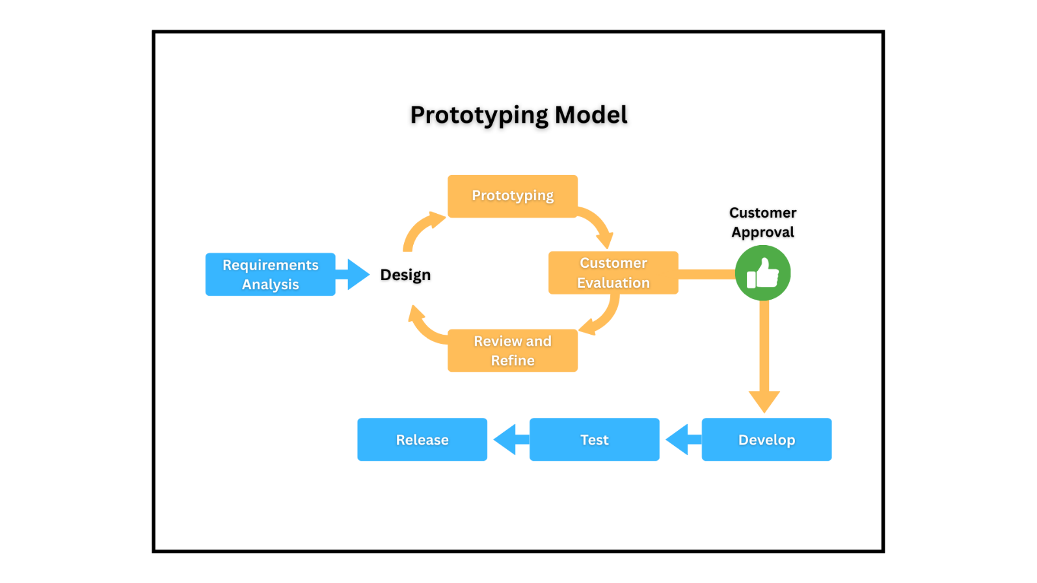*Prototype Model*

The following are the phases of the Prototypemethod that the researchers used in this study:

1. **Requirements Analysis.** During this phase, the researchers carried out key foundational activities to initiate their study. They began with a brainstorming session to define the project's direction, scope, and goals, which led to the creation of a clear and focused study title. After presenting the title for approval in a title hearing, they proceeded to draft Chapter 1, covering essential components such as the introduction, background, problem statement, objectives, scope, significance, and definition of terms. To enhance the study and guide system design, the researchers conducted stakeholder interviews, documented the gathered requirements, and developed a formal requirement specification. With these in place, they finalized Chapter 1 and moved on to draft and complete Chapter 2, which provided a review of related literature and established a solid academic foundation for their research.
2. **Design.** In the Design phase, the researchers focused on shaping the system’s structure and user experience. They began by drafting Chapter 3, which outlines the methodology and technical approach of the project. This was followed by defining the system architecture to establish the system’s overall framework and components. With the architecture in place, the team designed the UI/UX, ensuring the interface would be user-friendly and aligned with user needs. They then prepared the necessary design documentation to formally present their design decisions. Finally, they finalized Chapter 3, integrating all design elements and ensuring alignment with the project’s goals and requirements.
3. **Prototyping.** In the Prototyping phase, the researchers developed the initial version of the system to translate their design into a working model. This prototype served as a functional representation of the core features and interface. Once completed, the team conducted an internal review to assess its performance, gather feedback, and identify areas for improvement before proceeding to further development stages.
4. **Customer Evaluation.** In the User Evaluation phase, the researchers presented a system demo to actual users to showcase the prototype’s functionality and usability. Following the demonstration, they collected user feedback to gain insights on the system’s strengths, weaknesses, and areas for improvement, ensuring the design aligns with user needs and expectations.
5. **Review and Refine.** In the Review and Refine phase, the researchers improved the prototype based on user feedback and internal evaluation. They updated system features, interface elements, and functionality to address identified issues. Additionally, they reviewed and adjusted the documented requirements if necessary, ensuring the system remained aligned with user needs and project goals.
6. **Develop.** In this phase, the researchers focused on building the complete system. They worked on frontend coding to implement the user interface and ensure a responsive, user-friendly experience. Simultaneously, backend development was carried out to build the system’s logic and functionalities. During this time, database integration was also performed to enable data storage, retrieval, and management, resulting in a fully functional and cohesive system.
7. **Testing.** During this phase, the researchers focused on identifying and fixing bugs to ensure the system’s stability and performance. They conducted thorough system testing to verify that all components functioned correctly and met requirements. Finally, they prepared a deployment plan to guide the system’s rollout and implementation.
8. **Release.** In this phase, the researchers set up the deployment environment and completed the final deployment of the system. Following deployment, they conducted user training sessions and provided documentation to ensure users could effectively operate and maintain the system.

**Operational Framework**

Figure 2 illustrates the operational framework of *Anatomy Quest: A 2D Interactive Learning Game*, highlighting its two main users: the student and the teacher. Students interact with the system by viewing and navigating modules, reading stories, and taking quizzes. Teachers manage and upload modules, add stories, upload and manage quizzes, and generate reports. All data—such as modules, stories, and quizzes—is stored and retrieved from a cloud-based Firebase database. The system relies on a stable internet connection to ensure smooth communication between users and the database.

**Figure 2**

*Operational Framework*

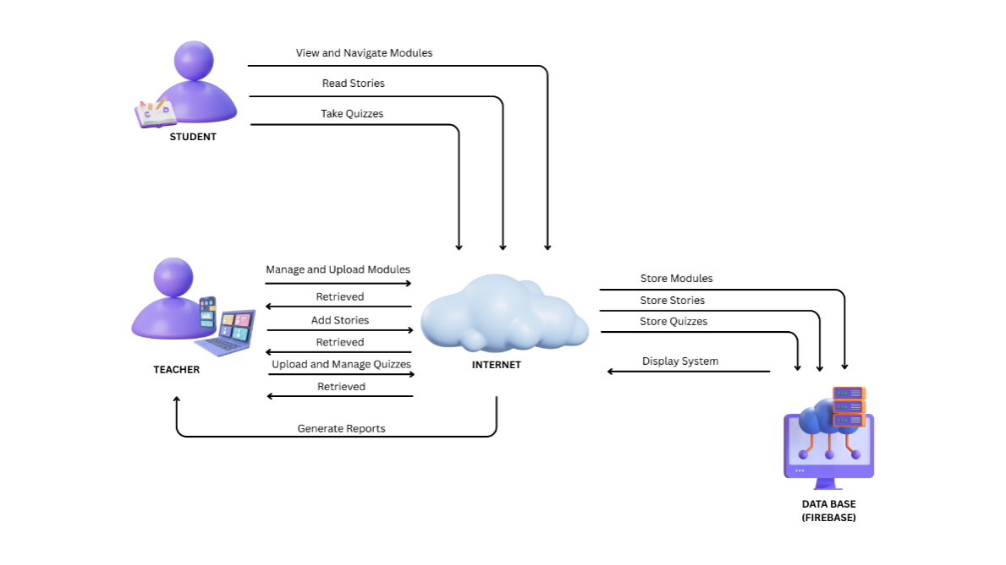

**Context Diagram (Level 0)**

The diagram shown illustrates and summarizes the details of the Anatomy Quest: Interactive Learning Platform users—Teacher and Student—along with their interactions with the system. In the platform, teachers log in to manage educational content by handling modules, uploading lessons, managing stories, and creating quizzes. On the other hand, students access the system to view lessons and stories, take quizzes, and play educational games designed to enhance interactive learning.

**Figure 3**

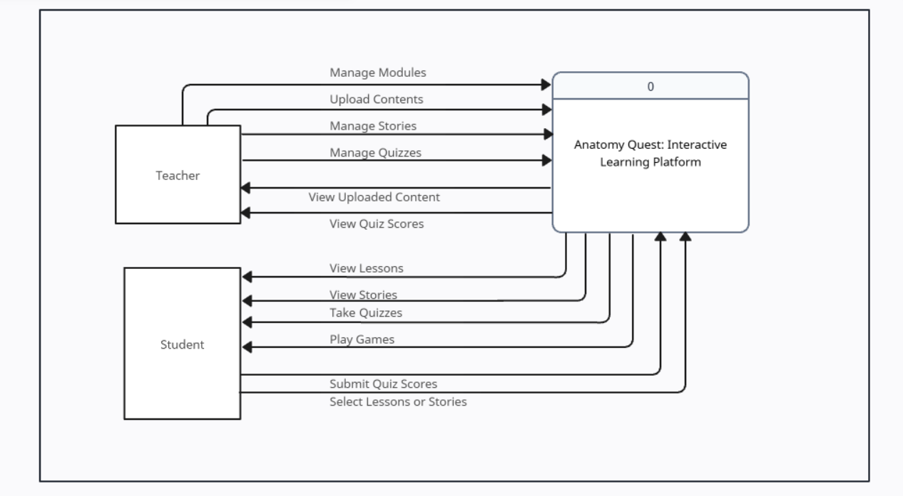*Context Diagram(Level 0)*

**Data Flow Diagram (Level 1)**

Figure 4 illustrates the detailed version of the context diagram, clearly mapping out every transaction flow of the users within the system through a data flow diagram. Using directional arrows, the processes between learners, teachers, and the database are explicitly shown—highlighting how students access modules, play games, and track progress, while teachers upload lessons and manage quizzes, with all related data stored and retrieved from corresponding database tables.

**Figure 4**

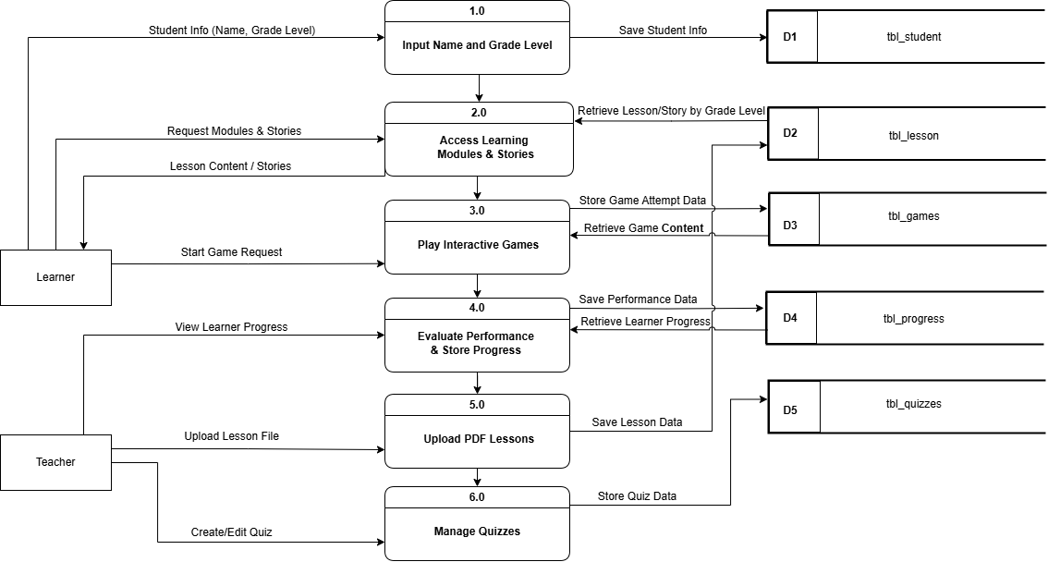*Data Flow Diagram (Level 1)*

**Entity Relationship Diagram**

Figure 5 illustrates the structured relationships among the entities within the database of the system. They help us to visualize how data is connected in a general way, and are particularly useful for constructing a relational database. (smartdraw.com, 2025 The database is organized using an Entity Relationship Diagram (ERD), which offers researchers a clear and detailed overview of the entire data model. This visual representation simplifies the process of identifying entities, analyzing their attributes, and understanding how they interact with one another. Consequently, researchers can thoroughly evaluate the database structure and detect any inefficiencies or design flaws. The ERD plays an essential role in ensuring that *Anatomy Quest: A 2D Interactive Learning Game* operates smoothly and supports all intended features and capabilities.

**Figure 5**

*Entity Relationship Diagram*

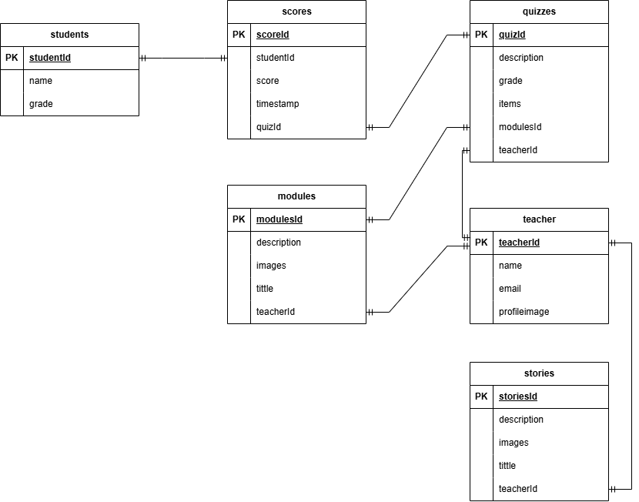

**Use Case Diagram**

The diagram shown in Figure 6 illustrates and summarizes the user roles and interactions within the *Anatomy Quest: A 2D Interactive Learning Game*. The system involves two main users: the Student and the Teacher. Both users can log in and sign up to access the system. Once logged in, Teachers are responsible for managing educational content, which includes adding stories, uploading quizzes, and organizing learning modules. On the other hand, Students interact with the system by reading stories, viewing modules, and taking quizzes for learning purposes. This use case diagram clearly defines the functional boundaries between the two user types and highlights how each interacts with the features and functionalities of the game.

**Figure 6**

*Use Case Diagram(level 1)* 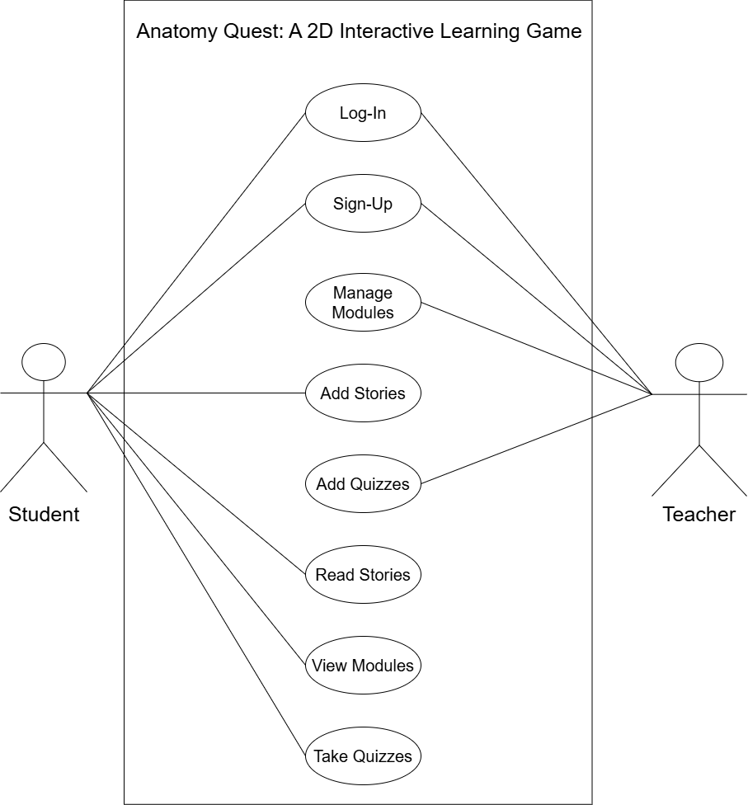

**Data Dictionary**

The system catalog is a compilation of names, definitions, and attributes of data elements utilized or stored within the system's database. It provides a detailed listing of object names, assigned data values, and the relationships defined for each table.

**Table 4. students Table**

*Actual students Table*

|  |  |  |  |
| --- | --- | --- | --- |
| **Field Name** | **Field Type** | **Length** | **Description** |
| name | String | 25 | Students name |
| grade | String | 25 | Students grade |
| timestamp | Timestamp | 25 | Date and time created |

Table 4 stores the student’s name, grade, and the timestamp to record when each student entry was created.

**Table 5. Teachers table**

*Actual Teachers table*

|  |  |  |  |
| --- | --- | --- | --- |
| **Field Name** | **Field Type** | **Length** | **Description** |
| name | String | 25 | Teachers name |
| profileimage | String | 25 | Teachers image |

Table 5 stores the teacher’s name and profile image for identification and display purposes.

**Table 6. modules table**

*Actual modules table*

|  |  |  |  |
| --- | --- | --- | --- |
| **Field Name** | **Field Type** | **Length** | **Description** |
| id | String | 25 | Modules id |
| description | String | 25 | Modules descriptions |
| image | String | 25 | Studens image |
| tittle | String | 25 | Modules tittle |
| grade | String | 25 | Students grade |

Table 6 stores information about learning modules, including module ID, title, description, related student grade, and an associated image.

**Table 7. stories table**

*Actual stories table*

|  |  |  |  |
| --- | --- | --- | --- |
| **Field Name** | **Field Type** | **Length** | **Description** |
| id | String | 25 | Stories id |
| descriptions | String | 25 | Stories descriptions |
| Image | String | 25 | Stories image |
| Title | String | 25 | Stories tittle |
| Pages | Array | 25 | Stories pages |

Table 7 stores story-related information, including the story ID, title, description, image, and an array of pages that make up the story.

**Table 8. quizzes table**

*Actual quizzes table*

|  |  |  |  |
| --- | --- | --- | --- |
| **Field Name** | **Field Type** | **Length** | **Description** |
| Id | String | 25 | Quizzes id |
| descriptions | String | 25 | Quizzes descriptions |
| grade | String | 25 | Stdents grade |
| items | String | 25 | Quizzes items |

Table 8 stores quiz details, including the quiz ID, description, associated student grade, and the list of quiz items.

**Table 9. scores table**

*Actual scores table*

|  |  |  |  |
| --- | --- | --- | --- |
| **Field Name** | **Field Type** | **Length** | **Description** |
| id | String | 25 | Scores id |
| quiz id | String | 25 | Connected to quizes id |
| Students id | String | 25 | Connected to students id |
| Base scores | Number | 25 | Base points |
| Bunos point | Number | 25 | Bunos points |
| Timestamp | Timestamp | 25 | Date and time created |
| Scores | Number | 25 | Scores points |

Table 9 stores students’ quiz scores, including the score ID, associated quiz and student IDs, base score, bonus points, total score, and the timestamp of when the record was created.

**Table 10**

**Hardware Requirements**

*Server and Client (Desktop Computer)*

The following hardwa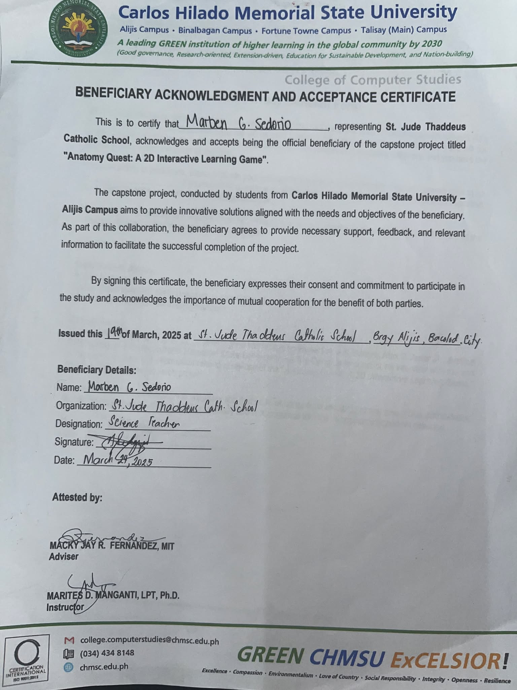re elements and standards are necessary to access the system:

|  |  |
| --- | --- |
| **Hardware Component** | **Minimum Specification** |
| **CPU**    **RAM**  **Hard Disk**  **Monitor Resolution**  **Network Connectivity**  **Development Environment**  **Operating System** | Intel or AMD processor with 64-bit support; 1.10 GHz or faster  4GB or Higher  500GB of free disk space or higher  1280x800; Recommended: 1920 x 1080  10Mbps; Bandwidth: 512kbps  Javascript, Tailwind CSS, React JS, Node JS, Firebase  Windows 11 |

**Table 11**

**Hardware Requirements**

*Android Tablet*

The following hardware components and specifications for android smartphones are as follows:

|  |  |
| --- | --- |
| **Hardware Component** | **Minimum Specification** |
| RAM | Dual-core 1.2GHz |
| Storage | 4 GB minimum |
| Operating System | 64 GB minimum |
| Display | Android 10 and above |
| Internet Connectivity | Optimize for various screen sizes |
|  | 10 Mbps; Bandwidth: 512kpbs |

**Software Requirements**

In developing the system, the researchers utilized React.js with Vite as the front-end development framework to ensure fast builds and optimized performance. The project used Tailwind CSS version 3.4.17 for utility-first and responsive design.

Vite, a modern frontend build tool, was chosen for its fast development server and optimized production builds. The system was developed using Visual Studio Code (VS Code) as the Integrated Development Environment (IDE), with Node.js version 18.x or higher and npm version 9.x or higher for package and dependency management. For local development, the system runs on localhost:5173, served by the Vite development server. The platform is responsive and compatible with both web and mobile views. If dynamic data storage and user management are required, Firebase (including Firestore, Authentication,) may be integrated for real-time database and cloud services.

**Minimum Software Specifications:**

Operating System: Windows 10 or higher / macOS / Linux

Web Browser: Latest version of Google Chrome, Mozilla Firefox, or Microsoft Edge

Node.js: v18.x or later

npm: v9.x or later

Code Editor: Visual Studio Code

Development Server: Vite (localhost:5173)

Optional Backend: Firebase (Firestore, Authentication)

This setup ensures a modern development environment with fast performance, modular component structure, and responsive design suitable for educational platforms targeting primary school students.

**Timetable (Gantt Chart)**

Using a software development approach, the Gantt Chart is utilized to outline and organize all sub-activities within each phase of the Prototype model. A Gantt chart is a commonly used graphical depiction of a project schedule. It’s a type of bar chart showing the start and finish dates of a project’s elements, such as resources, planning, and dependencies. The Gantt chart is the most widely used chart in project management. These charts are useful in planning a project and defining the sequence of tasks that require completion (Grant, 2024)

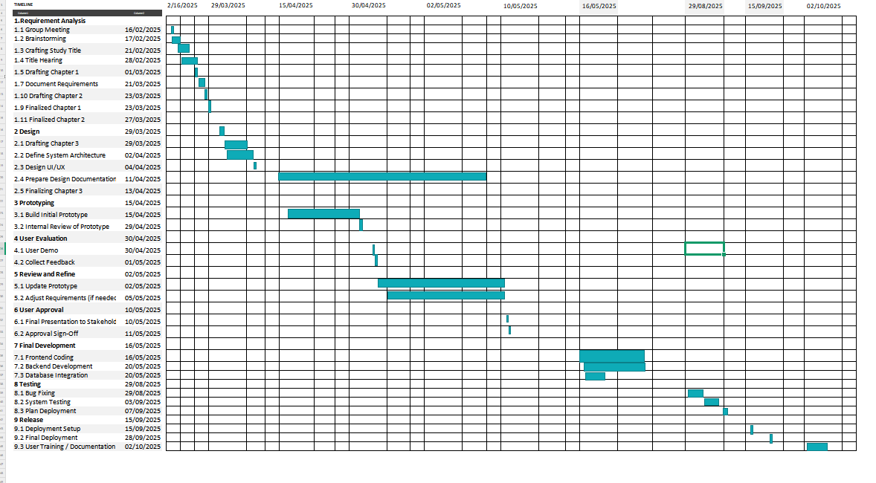**Figure 7.** *Gantt Chart*

**REFERENCES**

**Published Books / Journals:**

Al-Kindi, I. R., & Al-Khanjari, Z. (2021). Tracking Student Performance Tool for Predicting Students EBPP in Online Courses. *International Journal of Emerging Technologies in Learning (iJET)*, *16*(23), pp. 140–157. https://doi.org/10.3991/ijet.v16i23.25503

Feoktistov, A. V., Trofimenko, O. N., Ognev, S. P., Lyakhovets, M. V., & Koynov, R. S. (2020). Digital Platform as a professional education management tool. *Journal of Physics: Conference Series*, *1691*(1), 012058. https://doi.org/10.1088/1742-6596/1691/1/012058

Sergeev, A., Kulikova, N., Danilchuk, E., & Borisova, N. (2021). Online educational platform as a web content management system in the organization of student-teacher interaction. Lecture Notes in Networks and Systems, 846–856. https://doi.org/10.1007/978-3-030-90321-3_70

Sherayzina, R. M., Monakhova, L. Yu., & Maron, A. E. (n.d.). *Chapter 3: Educational content management in information and learning environments*. European Proceedings of Social and Behavioural Sciences. https://www.europeanproceedings.com/article/10.15405/epsbs.2020.08.02.3

Kaur, R., Gupta, D., Madhukar, M., Singh, A., Abdelhaq, M., Alsaqour, R., Breñosa, J., & Goyal, N. (2022). E-Learning Environment Based Intelligent Profiling System for Enhancing User Adaptation. *Electronics*, *11*(20), 3354. https://doi.org/10.3390/electronics11203354

Kubrak, H., Ehlers, M., Piecha, K., Walcher, T., Braun, G., & Prade, P. (n.d.). *EXaHM – application oriented, digital examination system at Hochschule München*. Electronic Journal of e-Learning. https://academic-publishing.org/index.php/ejel/article/view/3001

Lamrani, R., & Abdelwahed, E. (2020). Game-based learning and gamification to improve skills in early years education. *Computer Science and Information Systems*, *17*(1), 339–356. https://doi.org/10.2298/csis190511043l

Bains, M., Kaliski, D. Z., & Goei, K. A. (2022). Effect of self-regulated learning and technology-enhanced activities on anatomy learning, engagement, and course outcomes in a problem-based learning program. *Advances in Physiology Education*, 46(2), 219–227. <https://doi.org/10.1152/advan.00039.2021>

Astuti, L., Wihardi, Y., & Rochintaniawati, D. (2020). The development of web-Based Learning Using Interactive Media for science learning on levers in human body topic. *Journal of Science Learning*, *3*(2), 89–98. https://doi.org/10.17509/jsl.v3i2.19366

Wang, W., Rao, Y., Zhi, R., Marwan, S., Gao, G., & Price, T. W. (2020). Step tutor: Supporting students through step-by-step example-based feedback. *Proceedings of the 2020 ACM Conference on Innovation and Technology in Computer Science Education*, 391–397. https://doi.org/10.1145/3341525.3387411

Doulougeri, K., Vermunt, J. D., Bombaerts, G., & Bots, M. (2024). Challenge‐Based learning implementation in engineering education: A systematic literature review. *Journal of Engineering Education*, *113*(4), 1076–1106. <https://doi.org/10.1002/jee.20588>

Bayounes, W., Sa&acirc;di, I. B., & Kinshuk. (2022, December 19). *Adaptive learning: Toward an intentional model for learning process guidance based on learner’s motivation - smart learning environments*. SpringerLink. https://link.springer.com/article/10.1186/s40561-022-00215-9

Chang, L.-J., Yang, J.-C., & Yu, F.-Y. (2020). Development and evaluation of multiple competitive activities in a synchronous quiz game system. *Innovations in Education and Teaching International*, *40*(1), 16–26. https://doi.org/10.1080/1355800032000038840

Borrelli, L., & Perrella, S. (2021, October). User interface design for e-learning platform and institutional portal of University of Foggia. In *teleXbe (2)*.

Zainuddin, Z., Shujahat, M., Haruna, H., & Chu, S. K. (2020). The role of gamified e-quizzes on student learning and Engagement: An interactive gamification solution for a formative assessment system. *Computers &amp; Education*, *145*, 103729. https://doi.org/10.1016/j.compedu.2019.103729

Hellín, C. J., Calles-Esteban, F., Valledor, A., Gómez, J., Otón-Tortosa, S., & Tayebi, A. (2023). Enhancing student motivation and engagement through a gamified learning environment. *Sustainability*, *15*(19), 14119. https://doi.org/10.3390/su151914119

Xiao, Y., & Hew, K. F. (2023). Intangible rewards versus tangible rewards in gamified online learning: Which promotes student intrinsic motivation, behavioural engagement, cognitive engagement and learning performance? *British Journal of Educational Technology*, *55*(1), 297–317. <https://doi.org/10.1111/bjet.13361>

Miri, D. H., & Macke, J. (2021). Gamification, motivation, and engagement at work: A qualitative multiple case study. *European Business Review*, *34*(2), 263–276. https://doi.org/10.1108/ebr-04-2020-0106

1. **Online Sources:**

Yusuf, B. D. M. (2023, June 27). *SIGNIFICANCE OF THE STUDY – Dr. Muchelule Yusuf*. https://drmuchelule.com/2023/06/27/significance-of-the-study/#:~:text=The%20significance%20of%20the%20study,others%20will%20benefit%20from%20it.

Gillis, A. S. (2024, October 22). *What is an application?* Search Software Quality. https://www.techtarget.com/searchsoftwarequality/definition/application

Feder, M. (2023, June 18). *What is a dean?*  University of Phoenix. https://www.phoenix.edu/blog/college-dean-job-description.html#:~:text=A%20dean%20of%20faculty%20serves,needs%20with%20the%20academic%20leadership.

Yasar, K. (2023, November 1). *What is Digital?* techtarget.com. https://www.techtarget.com/whatis/definition/digital

Elçi, A. (2019). *What is Faculty*. igi-global.com. https://www.igi-global.com/dictionary/faculty-development-centers-for-digital-teaching-and-learning/10855

Herrity, J. (2025, January 29). *What is Management?* Indeed. https://www.indeed.com/career-advice/career-development/what-is-management

Hall, J. (2019). *Monitoring*. Better Evaluation. https://www.betterevaluation.org/methods-approaches/themes/monitoring#:~:text=Monitoring%20is%20a%20process%20to,implementation%20in%20advance%20of%20evaluations.

Bonifacio, R. (2025, February 17). Leave of absence Meaning, duration and best practices for employers - Shiftbase. *Shiftbase*. https://www.shiftbase.com/glossary/leave-of-absence

Kelvin. (2022, October 5). *Official Business vs. Certificate of Attendance--Which One Should I File?* Sprout Solutions. https://sprout.zendesk.com/hc/en-us/articles/360030543034-Official-Business-vs-Certificate-of-Attendance-Which-One-Should-I-File#:~:text=To%20start%2C%20let%20me%20differentiate%20the%20two:,is%20nearing%20her%20expected%20date%20of%20delivery.

Hayes, A. (2025, March 5). *Quick Response (QR) code: definition and how QR codes work*.Investopedia.https://www.investopedia.com/terms/q/quick-response-qr-code.asp

Miller, J., & Jones, R. (2013). Security Personnel. *Personnel Protection: Security Personnel*. https://www.sciencedirect.com/science/article/abs/pii/B9780124172296000011

Chappelow, J. (2024, July 31). *Statistics: Definition, types, and importance*. Investopedia.

schedule. (2025). In *Merriam-Webster Dictionary*. https://www.merriam-webster.com/dictionary/schedule

Kmcfadden. (2010, March 1). *What is a Record?* Armedia. https://armedia.com/blog/what-is-a-record/

*attendance noun - Definition, pictures, pronunciation and usage notes | Oxford Advanced Learner’s Dictionary at OxfordLearnersDictionaries.com*. (n.d.). https://www.oxfordlearnersdictionaries.com/us/definition/english/attendance

1. Dictionary.com | Meanings & Definitions of English Words. (2025). In *Dictionary.com*. https://www.dictionary.com/browse/staff

Bisht, R. (2024, April 27). What is Purposive Sampling? Methods, Techniques, and Examples | Researcher.Life. https://researcher.life/blog/article/what-is-purposive-sampling-methods-techniques-and-examples/

Laptick, S. (2025, March 27). Prototype model in software development life cycle (SDLC). XB Software. https://xbsoftware.com/blog/prototype-model-sdlc/#:~:text=The%20prototyping%20model%20is%20an,your%20customer%20will%20consider%20satisfactory.

*Entity Relationship Diagram (ERD) - What is an ER Diagram?* (n.d.). https://www.smartdraw.com/entity-relationship-diagram/#:~:text=ERD%20diagrams%20are%20commonly%20used,for%20constructing%20a%20relational%20database.

Grant, M. (2024, August 14). *Gantt Chart: Definition, Benefits, and How it’s used*. Investopedia. https://www.investopedia.com/terms/g/gantt-chart.asp

McCombes, S. (2023, June 22). Descriptive Research | Definition, Types, Methods & Examples. Scribbr. Retrieved May 21, 2025, from https://www.scribbr.com/methodology/descriptive-research/

**APPENDICES**

**Appendix A**

**Transmittal Letter Adviser’s**

**Endorsement Form**

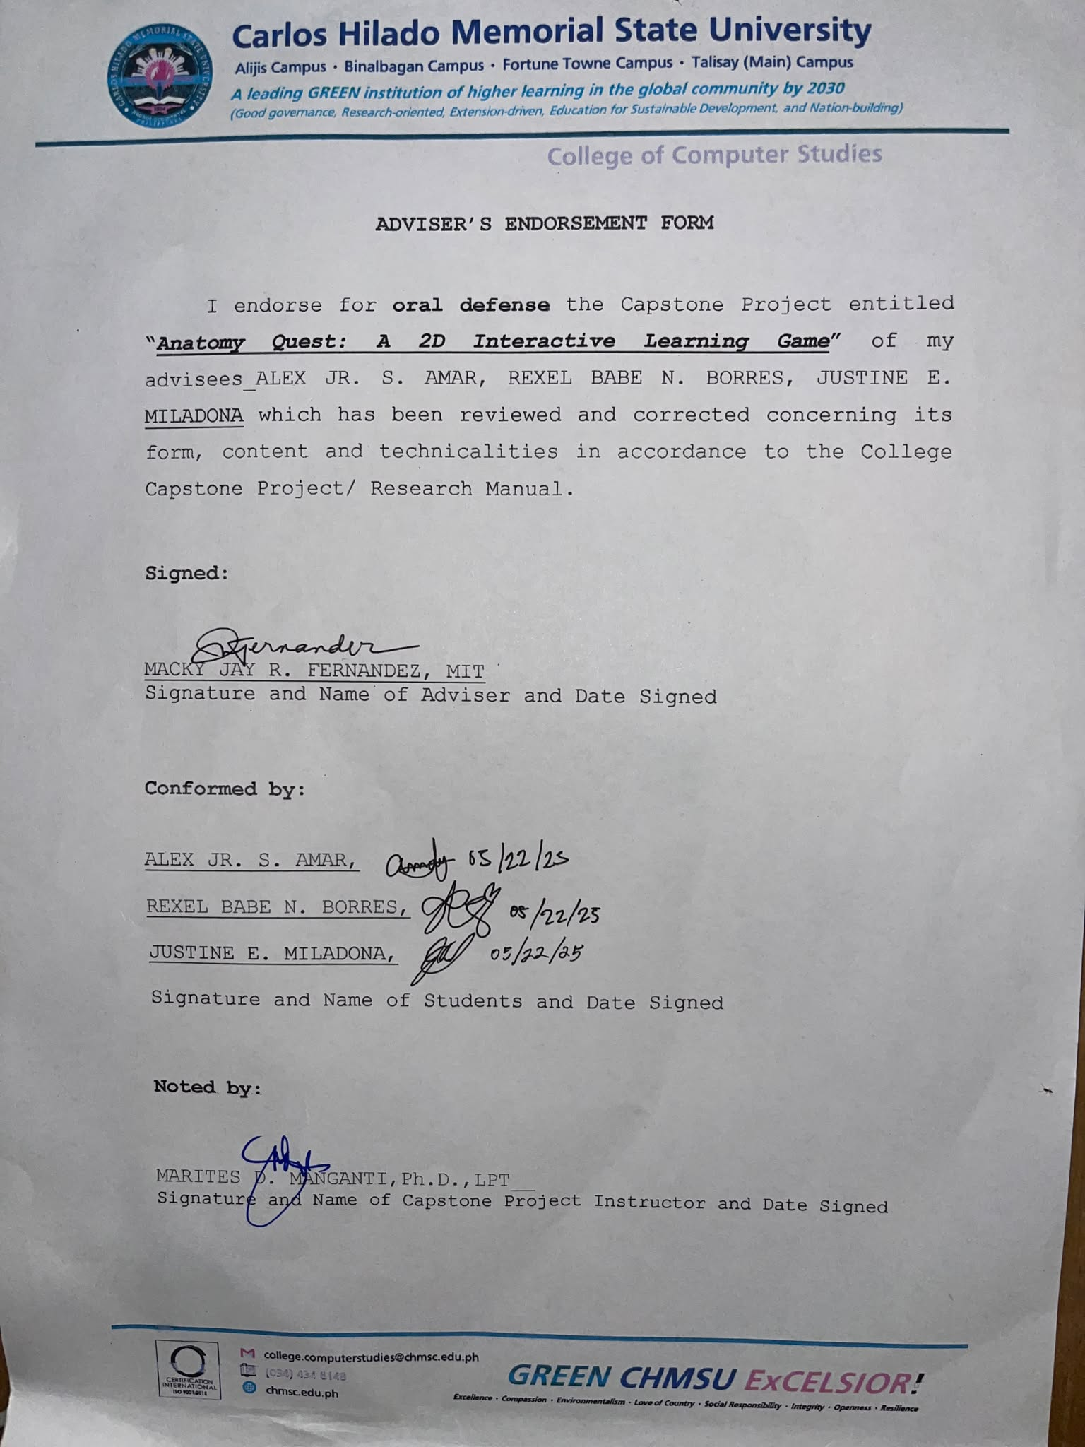

**Letter For Beneficiary**



**Letters for System Testers**

**Test Case**

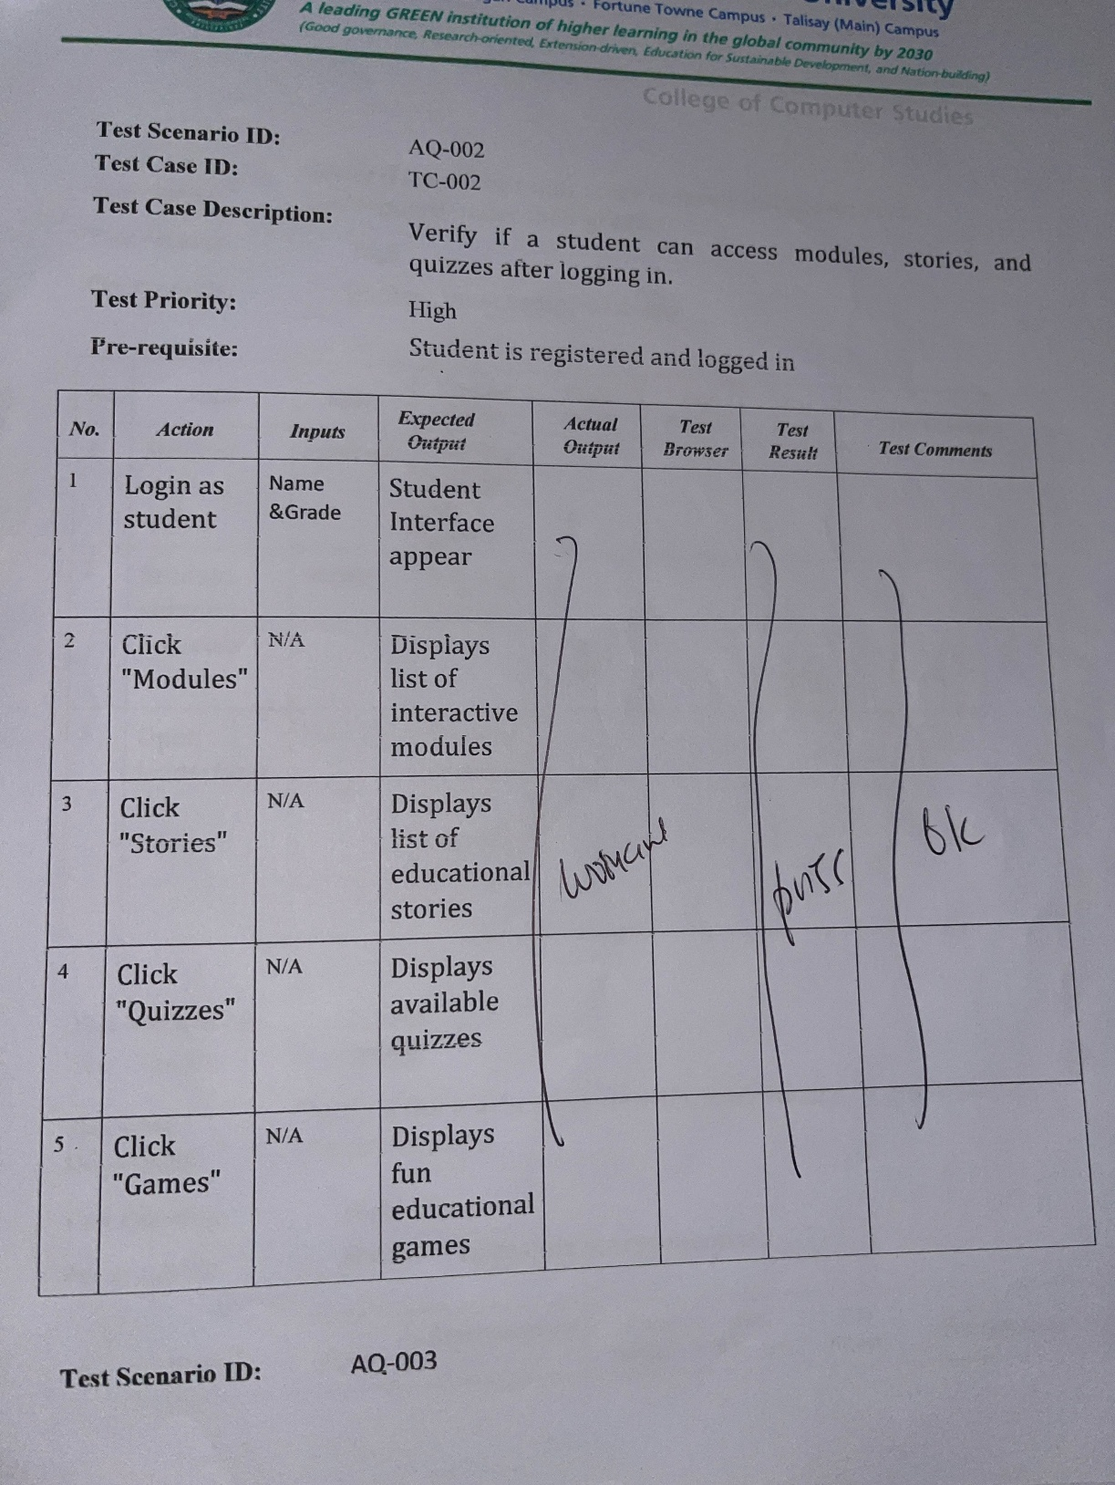

**Appendix B**

**Forms/Questionnaires**

**Data Privacy Form**

1. **Appendix C**

**Test Case Results and Interpretations**

|  |  |  |  |  |
| --- | --- | --- | --- | --- |
| **TEST CASE ID** | **Description** | **Expected**  **Output Met?** | **Test**  **Result** | **Tester Comments** |
| **TC_001** | **Verify if the student can register and log in using their name and grade level** | **Yes** | **Passed** |  |
| **TC_002** | **Verify if a student can access modules, stories, and quizzes after logging in.** | **Yes** | **Passed** |  |
| **TC_003** | **Verify if a student's quiz score is saved and shown in the leaderboard under their grade.** | **Yes** | **Passed** |  |
| **TC_004** | **Verify if the teacher can view the leaderboard by grade and see top performers** | **Yes** | **Passed** |  |
| **TC_005** | **Verify if the teachers can add new quizzes and stories from their dashboard.** | **Yes** | **Passed** |  |
| **TC_006** | **Verify if learners can select grade level, take quizzes and have records saved to leaderboards** | **Yes** | **Passed** |  |
| **TC_007** | 1. **Verify if the learner can play Game 1 by entering a name, selecting difficulty based on an organ, tracing it successfully, and continuing to trace additional organs.** | **Yes** | **Passed** |  |
| **TC_008** | **Verify if the learner can play Game 2 by entering a name, selecting a grade level, dragging and dropping organs, and answering corresponding questions before continuing** | **Yes** | **Passed** |  |
| **TC_009** | **Verify if the teacher can edit or delete quizzes in the system** | **Yes** | **Passed** |  |
| **TC_010** | **Verify if the teacher can sign up, log in using registered email and password, and reset their password via Gmail if forgotten.** | **Yes** | **Passed** |  |

The majority of the system features functioned as intended, confirming the system’s effectiveness in supporting both student and teacher activities. The tests verified that students can successfully register, log in, access educational content, and have their quiz results recorded and displayed on the leaderboard by grade level. Teachers were also able to view performance data, manage content, and perform account-related actions such as signing up and resetting passwords. Additionally, both Game 1 and Game 2 operated correctly, allowing learners to engage in interactive educational activities tailored to their grade and topic. All test cases passed, indicating a robust and user-friendly implementation of the system's core functionalities.